Agenda Item 2/05

= application site



1-20 Canons Park Close | P/1277/20

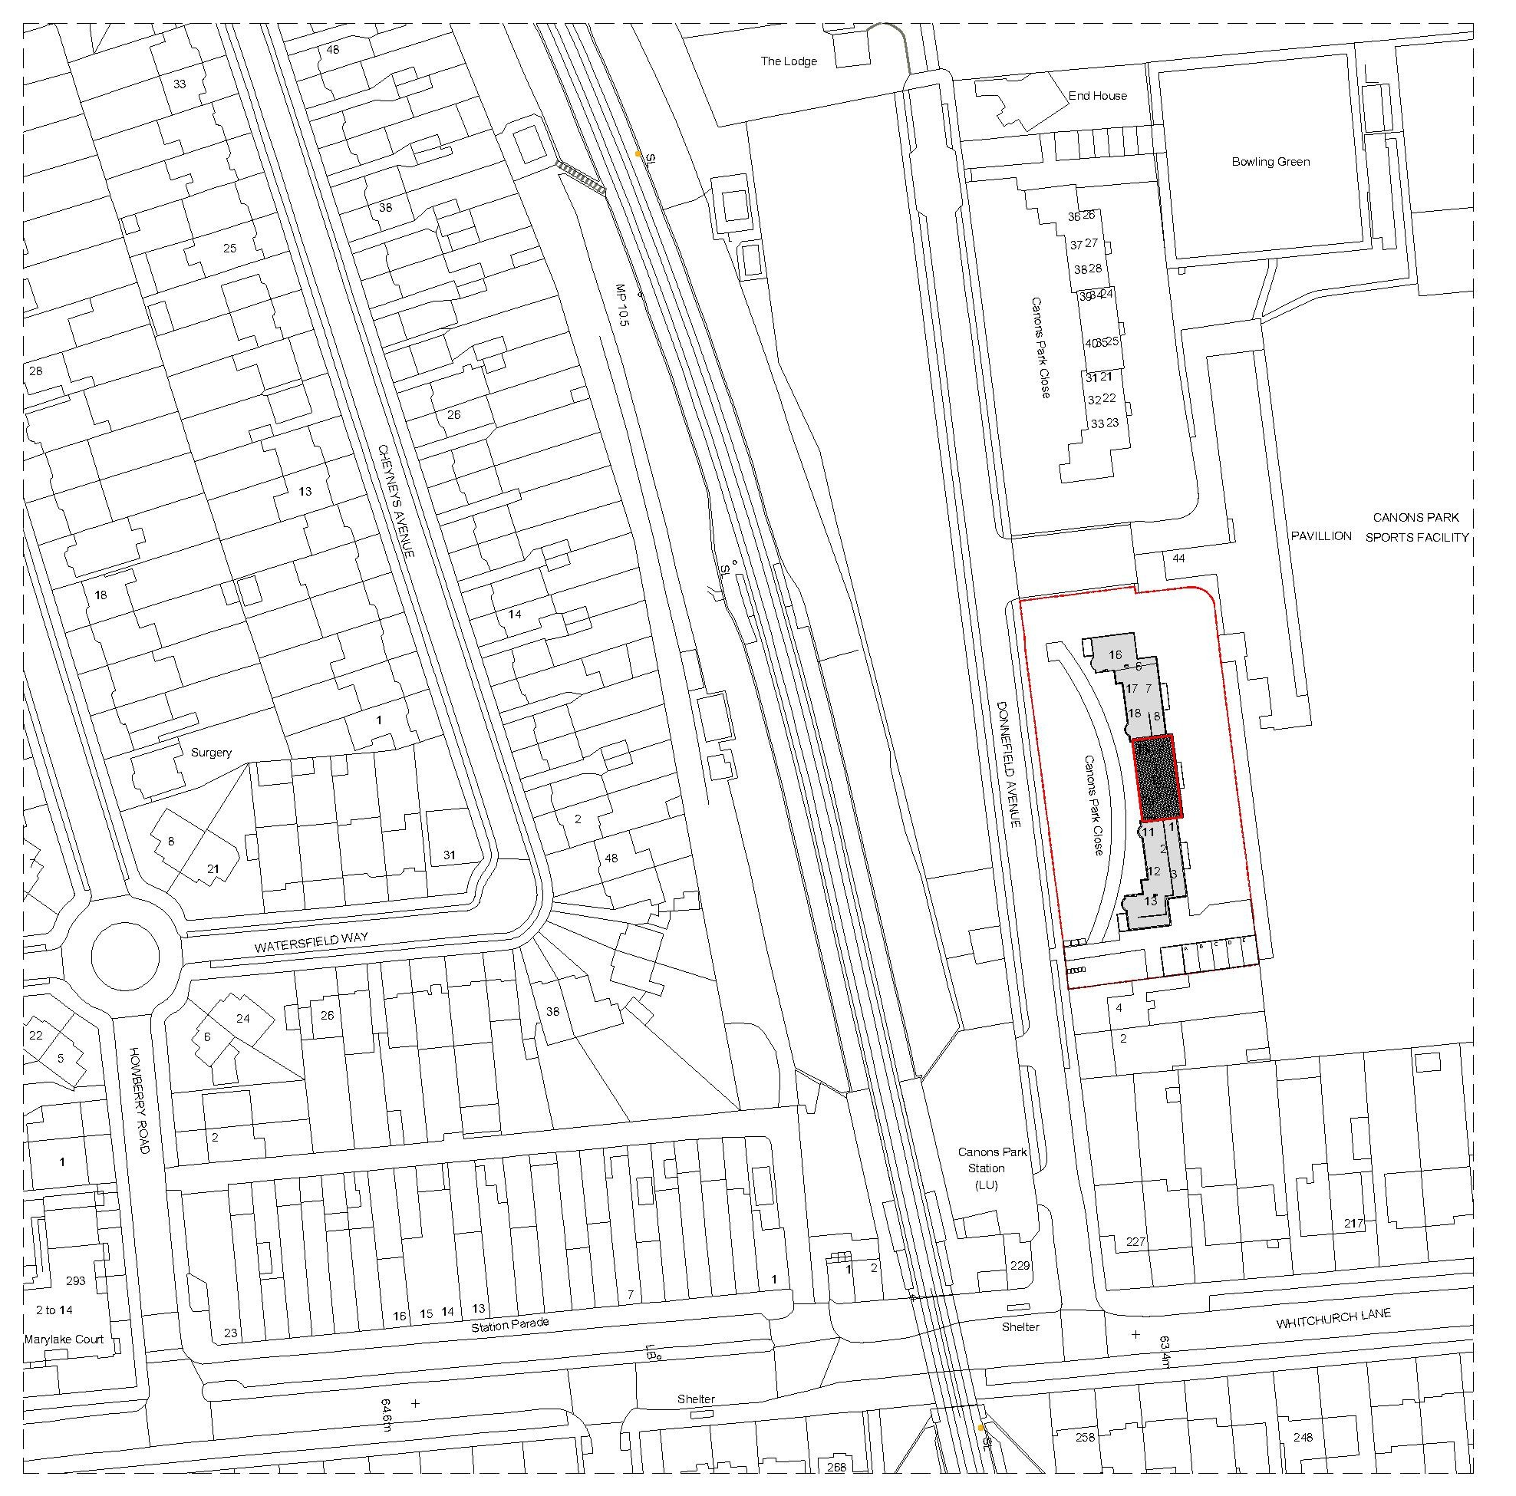
Location Plan

LONDON BOROUGH OF HARROW
PLANNING COMMITTEE

2nd September 2020

APPLICATION NUMBER: | P/1277/20
VALIDATE DATE: | 4TH MAY 2020
LOCATION: | 1-20 CANONS PARK CLOSE, DONNEFIELD AVENUE
WARD: | CANONS
POSTCODE: | HA8 6RJ
APPLICANT: | HAYSPORT PROPERTIES LTD
AGENT: | BROOKS/MURRAY ARCHITECTS
CASE OFFICER: | NABEEL KASMANI
EXTENDED EXPIRY DATE: | 9TH SEPTEMBER 2020

PROPOSAL

Creation of an additional floor to create 8 flats (8 X 1 Bed); Parking and cycle storage; refuse storage

RECOMMENDATION

The Planning Committee is asked to:

- agree the reasons for approval as set out in this report, and

- grant planning permission subject to the conditions listed in Appendix 1 of this report:

REASON FOR THE RECOMMENDATIONS

The proposal would respond appropriately to the site, local context, massing and architectural appearance and would bring forward housing provision of a satisfactory layout and design to ensure that the future occupiers would benefit from a high standard of living accommodation. Given the context of the site, the proposal would not unacceptably impact upon the adjacent heritage designations, amenity of neighbouring occupiers or biodiversity. Furthermore, the transport aspects of this proposal are considered to be in accordance with strategic and local transport policies.

Accordingly, weighing up the development plan policies and proposals, and other material considerations including comments received in response to notification and consultation as set out below, officers conclude that the proposed development is worthy of support.

INFORMATION

This application is reported to Planning Committee as it would provide the construction of more than three dwellings and therefore falls outside category 1(b) of Schedule 1 of the Scheme of Delegation.

Statutory Return Type: | (E)13 Minor Dwellings
Council Interest:  Net Additional Floorspace: | n/a  475m²
GLA Community Infrastructure Levy (CIL): | £28,500
Local CIL requirement: | £75,342

HUMAN RIGHTS ACT

The provisions of the Human Rights Act 1998 have been taken into account in the processing of the application and the preparation of this report.

EQUALITIES

In determining this application the Council has regard to its equalities obligations including its obligations under section 149 of the Equality Act 2010.

For the purposes of this application there are no adverse equalities issues.

S17 Crime & Disorder Act

Policies 7.3.B and 7.13.B of The London Plan and Policy DM1 of the Development Management Polices Local Plan require all new developments to have regard to safety and the measures to reduce crime in the design of development proposal. It is considered that the proposed access does not adversely affect crime risk.

- SITE DESCRIPTION

1.1 The application site consists of a part 2 storey, part 3 storey building comprising twenty flats located on the eastern side of Donnefield Avenue. The subject building is set back from the highway with generous soft landscaping around the building which serves as the communal amenity space. A block of detached garages is located abutting the southern boundary of the application site.

1.2 An identical building comprising flat numbers 21-49 Canons Park Close is located to the north of the application. No. 4 Donnefield Avenue, a semi-detached dwellinghouse, adjoins the application site to the south.

1.3 Adjoining the application site to the east is Arnold House School Playing Fields. The single storey pavilion is sited immediately adjacent to the application site along the north part of that shared boundary. The playing fields fall within the Grade II Historic Canons Park, which is also designated as Metropolitan Open Land and is within the Canons Park Conservation Area.

1.4 The application site has a public transport accessibility level (PTAL) of 3.

- PROPOSAL

2.1 The subject proposal is for the construction of an additional floor to provide 8 x 1 bed self-contained flats.

2.2 The additional storey would have a maximum height of 4.75m from the finished floor level to the proposed ridge and would follow the form of the host building with a hipped roof profile finish.

2.3 Access to the proposed flats would be via the existing stairwells located within the central block and northern and southern wings of the building.

2.4 The proposed flats would access the existing refuse storage which would have an increased capacity. Five additional parking spaces would be provided opposite the existing garage and would utilise the crossover at the southern part of the site. A cycle store providing twelve new cycle spaces would be sited adjacent to the existing garages.

- RELEVANT PLANNING HISTORY

Ref no. | Description | Status & date of decision
P/3837/19 | Creation of third floor to north and south wings comprising of 6 flats (6 x 1 bed); parking cycle storage | Granted:  04/02/2020

- CONSULTATION

4.1 A total of 53 consultation letters were sent to neighbouring properties regarding this application. The minimum statutory consultation period expired on 2nd June 2020.

4.2 A site notice was placed outside the application site on 7th May 2020. The application was advertised in the local press on 7th May 2020.

4.3 A total of 9 objections have been received. A summary of the responses received are set out below with officer comments in Italics:

Summary of Comments on original consultation
Character
Out of character; change visual aspect of this part of Canons Park Conservation Area; stairwell being covered will change the aesthetics to the exterior of the property;
This has been addressed in section 5.3 of the report

Residential Amenity
Loss of light; congestion and noise pollution; location of cycle and parking will result in loss of light and privacy to flat 1;
This has been addressed in section 5.4 of the report.

Highways and Parking
Cycle spaces will not be utilised;
The policies require cycle storage provision to encourage modal shift to more sustainable transport modes. The likely use of the cycle stores is therefore not a material consideration in this regard.

Ecology
Construction will impact trees and wildlife within the gardens
This has been addressed in section 5.7 of the report

Other
Concern whether existing building can withstand major development; will the residents be rehoused during the build? How will residents access the flats as new stairwell will reduce light and ventilation and increase noise and disruption; build should commence while Coronavirus is an issue due to social distancing measures;
An informative is included which requires adherence to the considerate contractor code of practice in relation to noise and hours of construction; the structural considerations of the proposal would be dealt with under building control regulations; the Government has provided guidance on how construction can proceed during the current Covid-19 pandemic and any proposed construction would need to comply in this regard.

4.4 Statutory and Non Statutory Consultation

4.5 The following consultations have been undertaken and a summary of the consultation responses received are set out below.

Consultee and Summary of Comments

LBH Conservation Officer
This proposal is in the setting of the Cnaons Park Conservation Area and the grade II listed registered park and garden. Given the scale, siting, design and trees, this would preserve the setting of these heritage assets in my view as long as materials and details were conditioned to be provided for approval to ensure they would match existing. The proposal would only be slightly taller in the centre than the previous approval for the site. A specific condition is also needed to state: brickwork bond to match the existing.

LBH Highways
The proposed level of parking and cycle parking appear to meet the requirements of the draft London Plan.

LBH Biodiversity Officer
No Comment

LBH Drainage
we have no objections to the proposed development but surface water details are required for new / extended parking area. The use of non-permeable surfacing impacts upon the ability of the environment to absorb surface water, and the hardsurfacing of the front gardens and forecourts lead to localised surface water flooding. Hence the requirement for surface water to be contained within site and discharged to ground via the use of permeable paving or other suitable options..

Permeable paving details which includes the a cross section of permeable paving construction and their maintenance plan should be submitted for our approval. Please note that a minimum of 250mm subbase for permeable paving should be proposed to provide adequate storage underneath.

If using non permeable paving, please request the applicant to provide surface water drainage details for the run-off from the car park. A drainage plan with full details of outlet and cross section of proposed storage along with details of a flow restrictor provided should be submitted for our approval. If the applicant wishes to discharge the surface water into the existing drainage system, please note that the discharge should be limited to 5l/s. Please be informed that the requested details can be conditioned

Conservation Area Advisory Committee
Adjoins Canons Park CA. The increased height/roof line and the increased bulk of the proposed development will detract from the openness of the views out of the CA, even more so than the previously approved application P/3837/19.
This would be a massive overdevelopment. Before we had a central block flanked by two lower wings; now they are all to be of about the same height, and the pleasing proportion is lost.

London Parks and Gardens Trust
- The height, bulk and outline of the proposed buildings will have a harmful impact on the historic character of the park and would become too dominant from many key locations within the park;
- The proposed design of additional units undermines the coherent design and detailing of the original building
- The imposition of an additional 8 units will cause unacceptable additional pressure on the amenity of the existing original units and parking and waste storage and disposal

5.0 POLICIES

5.1 Section 38(6) of the Planning and Compulsory Purchase Act 2004 requires that:

‘If regard is to be had to the Development Plan for the purpose of any determination to be made under the Planning Acts, the determination must be made in accordance with the Plan unless material considerations indicate otherwise.’

5.2 The Government has issued the National Planning Policy Framework [NPPF 2019] sets out the Government’s planning policies for England and how these should be applied, and is a material consideration in the determination of this application.

5.3 In this instance, the Development Plan comprises The London Plan 2016 [LP] and the Local Development Framework [LDF]. The LDF comprises The Harrow Core Strategy 2012 [CS], Harrow and Wealdstone Area Action Plan 2013 [AAP], the Development Management Policies Local Plan 2013 [DMP], the Site Allocations Local Plan [SALP] 2013 and Harrow Local Area Map 2013 [LAP].

5.4 While this application has been principally considered against the adopted London Plan (2016) policies, some regard has also been given to relevant policies in the Draft London Plan (2019), as this will eventually replace the current London Plan (2016) when adopted and forms part of the development plan for the Borough.

5.5 The document was originally published in draft form in December 2017 and subject to Examination in Public (EiP) with the Panel’s report published in October 2019. The Mayor of London has considered these recommendations, and has either accepted them or where not, provided justification as to why accepting them would not be appropriate. The Mayor has now submitted to the Secretary of State an ‘Intend to Publish’ version of The Plan. It is for the Secretary of State to determine whether he agrees with the revised Plan and it ought to be published in that form.

5.6 The Draft London Plan is a material planning consideration that holds significant weight in determining planning applications, with relevant polices referenced within the report below and a summary within Informative 1.

6.0 ASSESSMENT

6.1 The main issues are;

  - Principle of the Development
  - Character, Appearance and Heritage
  - Residential Amenity
  - Transport and Parking
  - Flood Risk and Drainage
  - Biodiversity

6.2 Principle of Development

6.2.1 The relevant policies are:
- National Planning Policy Framework (2019)
- The London Plan (2016): 3.3, 3.8
- The Draft London Plan (2019): H1
- Harrow Core Strategy (2012): CS1, CS10
- Harrow Development Management Policies (2013): DM40

6.2.2 Having regard to Policy 3.8 of the London Plan (2016), it is considered that the proposed flats would provide an increase in smaller housing stock within the Borough, thereby complying with the housing growth objectives and policies of the Harrow Development Plan. The principle of development is therefore considered acceptable.

6.2.3 The application site adjoins Canons Park to the east, which is designated as Metropolitan Open Land. Given the modest increase in height of the proposal, the siting away from the boundary and the intervening trees and screening, officers consider that the proposal would not have a materially harmful impact on the openness/visual amenities of the Metropolitan Open Land.

6.3 Character, Appearance and Heritage

6.3.1 The relevant policies are:
- National Planning Policy Framework (2019)
- The London Plan (2016): 7.4, 7.6, 7.8
- The Draft London Plan (2019): D1, HC1
- Harrow Core Strategy (2012): CS1,
- Harrow Development Management Policies (2013): DM1, DM7

6.3.2 The application site consists of a block of flats on the east side of Donnefield Avenue. The block of flats has twin flat-roofed two-storey wings arranged in two staggered rectangular blocks and a central three storey section which features a hipped roof. An identical block of flats is located to the north of the application site. Adjoining the application site to the east is Arnold House School Playing Fields which falls within the Grade II Historic Canons Park, Metropolitan Open Land and Conservation Area. Across Donnefield Avenue from the application site is the car park for the Canons Park London Underground Station.

6.3.3 Planning permission P/3837/19 approved the addition of a third floor to the twin flat-roofed two-storey wings. The subject proposal incorporates this approved permission with an additional third floor extension over the central block. The addition of the proposed third floor to the central block would serve to replicate the architectural vernacular of the host building with a taller central element and subservient winged projections. Furthermore, given the relatively modest width of the central block in conjunction with a modest increase in height, this would serve to break up the mass and provide further articulation and relief in the built form.

6.3.4 The application site is within the setting of the Canons Park Conservation Area and grade II listed registered park and garden. The application was referred to the Council’s Conservation Officer who has advised that the proposal would preserve the setting of the heritage assets subject to conditions for materials and brickwork bond to match the existing.

6.3.5 The proposed extension would have a brick finish with a tiled hipped roof. In order to ensure a high quality palette of materials, key details such as materials and balconies will be secured by condition.

6.3.6 The submitted proposed site plan shows an increased refuse bin provision within the existing refuse storage area. Subject to a condition requiring further details of the external finish of the bin store and enclosure, it is considered that the proposal would be acceptable in this regard.

6.3.7 For these reasons, officers consider that the proposal would not have a detrimental impact on the character or appearance of the host building, the surrounding area or the Historic Grade II listed Canons Park and Conservation Area. The proposal would therefore comply with the relevant policies in this regard subject to appropriate conditions.

6.4 Residential Amenity

6.4.1 The relevant policies are:
- National Planning Policy Framework (2019)
- The London Plan (2016): 3.5, 7.6,
- The Draft London Plan (2019): D2, D4
- Harrow Core Strategy (2012): CS1
- Harrow Development Management Policies (2013): DM1, DM27, DM45,
- Mayor’s Housing SPG (2016)

Neighbouring Occupiers

6.4.2 The subject building is located 10m to the north of the shared boundary with no. 4 Donnefield Avenue. Given the separation distance, orientation and siting of that neighbouring dwellinghouse, it is considered that the proposed second floor extension to the southern wing of the host building would not have a detrimental impact on the residential amenities of those adjoining occupiers by reason of undue overshadowing, loss of light or loss of outlook.

6.4.3 The proposed north facing flank elevation of the second floor along the northern wing of the subject building would be sited approximately 30m away from the flank elevation of the adjacent flatted block, nos. 21-40 Canons Park Close. The proposal would therefore not have an unduly harmful impact on the residential amenities of those adjoining occupiers.

6.4.4 The pavilion serving Arnold House School Playing Fields is located approximately 18m to the east of the proposed extension. However, given the non-residential use of that building and the limited openings in the west elevation facing the subject property, it is considered that their amenity impact would be acceptable in this instance.

6.4.5 With regard to the impact of the proposal on the residential amenities of the existing occupiers, the proposed additional floor would result in vertical and horizontal stacking relationships with the existing first and second floor flats. While details of the existing floor layouts have not been provided, given the modest number of units proposed as an extension to the building and the soundproofing requirements which would be secured through building regulations, it is considered that the proposal would not have a detrimental impact on the residential amenities of the existing occupiers in this regard.

6.4.6 The proposal would provide 8 x one bedroom flats which could therefore increase the occupancy of the building by a further 16 persons. Given the scale of the subject building, its location, the setting space afforded and the numerous access points into the building, it is considered that the proposed residential intensification would not have a materially harmful impact on the amenity of the existing occupiers by reason of increased noise or disturbances by reason of trip generation.

6.4.7 Comments from neighbouring residents have referred to loss of light to the existing flats. It is acknowledged that the stairwell within the front elevation and balconies within the rear elevation would protrude beyond the main footprint of the building. A daylight and sunlight report has been submitted with the application. The report concludes that all the windows to habitable rooms would meet the target figure for the Vertical Sky Component and No Sky Line Assessment. Furthermore, 126 out of 127 windows assessed would pass the BRE Guidelines for Annual Probable Sunlight Hours (APSH) during the summer months, with all windows passing the APSH assessment for the winter months.

6.4.8 With regard to the continuation of the external stairwell on the front elevation, officers consider that the brick façade would result in an unfavourable relationship with the adjacent bay window for the first-floor flats. However, a more considered external finish to the external stairwell (e.g. through the use of obscured glazing), would be less obtrusive and allow for more light to penetrate through the adjacent bay window. Officers therefore consider that this detail could be satisfactorily addressed by means of a pre-commencement condition.

6.4.9 With regard to the proposed protruding balconies, these would sit centrally within the rear elevation of the staggered wings and the central block. The balconies sited within the middle of the rear elevation would be above the glazed windows and door which likely serve the kitchen and bathrooms for the first-floor flats. These windows are not ‘protected’ in accordance with the adopted Residential Design Guide SPD. Therefore, while it is considered that the loss of light to these windows would be limited, the resulting impact would nonetheless have an amenity impact commensurate with the adopted SPD. The balconies at the end of each wing would protrude 1.5m beyond the rear elevation but would be sited approximately 500mm above the windows on the first-floor. Therefore, while the balconies may result in the loss of some ambient daylight to those respective rooms, officers consider that the impact would not be harmful enough to warrant a reason for refusal on this basis.

6.4.10 The proposal would provide five parking bays adjacent to the rear elevation of the southern wing which would be sited perpendicular to the building. Given the layout of the parking bays, the limited number of parking spaces proposed and the established vehicular access at the southern part of the building, officers consider that this element of the proposal would not have a detrimental impact on the residential amenities of the adjoining occupiers.

6.4.11 For these reasons, the proposal subject to appropriate conditions, would comply with the relevant requirements of the policies with regard to residential amenity.

Future Occupiers

6.4.12 The proposed flats would adhere to or exceed the minimum space standards. Moreover, all the double bedrooms would be generously sized and would meet the minimum size and width requirements. All the flats would be dual aspect and therefore benefit from acceptable levels of light and outlook and would feature the minimum quantum of private amenity space. Officers consider that the proposed flats would provide a high quality of accommodation for the future occupiers and would accord with the relevant policies in this regard.

6.5 Traffic and Parking

6.5.1 The relevant policies are:
- National Planning Policy Framework (2019)
- The London Plan (2016): 6.3, 6.9, 6.13
- The Draft London Plan (2019): T4, T5, T6, T6.1
- Harrow Core Strategy (2012): CS1
- Harrow Development Management Policies (2013): DM42, DM44

6.5.2 The subject site has a PTAL 3 and therefore benefits from moderate accessibility to sustainable transport modes. The proposal would provide five new parking bays for the future occupiers which would accord with the draft London Plan with regard to maximum parking standards. Twelve cycle spaces would also be provided within a designated cycle store. The Council’s Highways Authority has raised no objection to the proposal. On this basis, it is considered that the proposal would not have a detrimental impact on the safety and functioning of the highway and would not result in undue parking stress within the locality.

6.6 Flood Risk and Drainage

6.6.1 The relevant policies are:
- National Planning Policy Framework (2019)
- The London Plan (2016): 5.13, 5.14
- The Draft London Plan (2019): SI13
- Harrow Core Strategy (2012): CS1
- Harrow Development Management Policies (2013): DM10

6.6.2 The Council’s Drainage Engineer has reviewed the proposal and raised no objection to the proposal, subject to safeguarding conditions and informatives. The proposal would therefore comply with the relevant policies in this regard.

6.7 Biodiversity and Trees

6.7.1 The relevant policies are:
- National Planning Policy Framework (2019)
- The London Plan (2016): 7.19, 7.21
- The Draft London Plan (2019): G6
- Harrow Core Strategy (2012): CS1
- Harrow Development Management Policies (2013): DM20, DM21, DM22

6.7.2 The application site lies in close proximity to the Canons Park and Stanmore Railway Embankments Sites of Interest for Nature Conservation which is of Borough Grade importance and forms a strategically important link in Harrow’s ecological network. The development should deliver net biodiversity gain. In this instance, this could be best achieved by installing and maintaining bat and bird boxes permanently within the fabric of the building. Subject to securing this by condition, the proposal would therefore comply with the relevant policies in this regard.

6.7.3 There are statutory protected trees located along the eastern boundary of the application site. Given the separation distance between the host building and the trees, and as the proposal is for an additional storey, it is considered that the proposed development would not have a detrimental impact on the protected trees. In order to safeguard the protected trees during the construction phase, a condition is included requiring the submission and approval of an Arboricultural Method Statement prior to commencement of development.

7.0 CONCLUSION AND REASONS FOR APPROVAL

6.1 The proposal would respond appropriately to the site, local context, massing and architectural appearance and would bring forward housing provision of a satisfactory layout and design to ensure that the future occupiers would benefit from a high standard of living accommodation. Given the context of the site, the proposal would not have unacceptable impact upon the adjacent heritage designations, amenity of neighbouring occupiers or biodiversity. Furthermore, the transport aspects of this proposal are considered to be in accordance with strategic and local transport policies.

6.2 For all the reasons considered above, and weighing up the development plan policies and proposals, and other material considerations including comments received in response to notification and consultation as set out above, this application is recommended for grant.

APPENDIX 1: Conditions and Informatives

Conditions

- Timing

The development hereby permitted shall be begun before the expiration of three years from the date of this permission.

Reason: To comply with the provisions of Section 91 of the Town and Country Planning Act 1990.

- Approved Plans and documents

Save where varied by the other planning conditions comprising this planning permission, the development hereby permitted shall be carried out, completed and retained in accordance with the following approved plans and documents:

1195.17-001, 1195.17-002 Rev A, 1195.17-010, 1195.17-011, 1195.17-020, 1195.17-030, 1195.17-100, 1195.17-200, 1195.17-300, 1195.17-500, Design and Access Statement (March 2020), Daylight and Sunlight Report (Rev 2: March 2020), Heritage Assessment

Reason: For the avoidance of doubt and in the interests of proper planning.

- Materials

Notwithstanding the details shown on the approved plans, the development hereby permitted shall not commence until samples of the external facing materials and brickwork bond details have been made available to view on site, and approved in writing by, the local planning authority. The relevant works shall be carried out in accordance with the approved sample details.

Reason: To enhance the appearance of the development and safeguard the character and appearance of the area. This is a pre-commencement condition to ensure a satisfactory form of development

- External Stairwell Details

Notwithstanding the details shown on the approved plans, the development hereby permitted shall not commence until revised drawings for the detailing and treatment of the external stairwells within the front elevation have been submitted to, and approved in writing by, the local planning authority. The development shall be carried out and retained in accordance with the approved details or any amendment or variation to it as may be agreed in writing by the local planning authority.

Reason: To safeguard the residential amenities of the neighbouring occupiers. This is a pre-commencement condition to ensure that measures are agreed and built-in to the development to provide a satisfactory form of development

- Bird and Bat Boxes

The development hereby permitted shall not be occupied until full details of the provision of bird and bat boxes to be installed within the fabric of the building have been submitted to, and agreed in writing by, the local planning authority. The enhancements shall include;
- Six Schwegler 2FR interconnecting bat tubes (or equivalent) in two groups of 3 at just below the new roof eaves level on the south elevation
- · Five Schwegler 17C double cavity swift nesting boxes (or equivalent) at just below the new roof eaves level on the north elevation
- · Two Schwegler 1SP sparrow terraces (or equivalent) at or just below the current maximum height on the north elevation of the existing building.
The development shall be carried out in accordance with the approved details or any amendment or variation to it as may be agreed in writing by the local planning authority, and maintained in accordance with the approved scheme. The development shall not be occupied until bird and bat boxes have been installed in accordance with the approved details. Photographs of the boxes in situ will be submitted to the Local Planning Authority prior to occupancy of the proposed units

Reason: To enhance the ecology and biodiversity of the area. This is a pre-commencement condition to ensure that measures are agreed and built-in to the development to provide a satisfactory form of development

- Arboricultural Method Statement and Tree Protection Plan

The development hereby permitted shall not commence until a detailed Arboricultural Method Statement and Tree protection Plan have been submitted to and approved in writing by the Local Planning Authority. The Arboricultural Method Statement shall contain full details of the following:
- sequence of operations
- tree protection methods
- tree protective fencing and ground protection
The development shall be carried out in accordance with the approved details.

Reason: The existing trees represent an important amenity feature which the Local Planning Authority considers should be protected. Details are required prior to commencement of development to ensure a satisfactory form of development.

- Permeable Paving

Notwithstanding the details submitted, the development hereby permitted shall not commence until full details of the permeable paving and the long term maintenance and management of the on-site drainage has been submitted to, and approved in writing by the Local Planning Authority. The development shall be carried out and retained in accordance with the approved details

Reason: To ensure that the development has adequate drainage facilities to reduce and mitigate the effects of flood

- Refuse Storage

Notwithstanding the approved plans, the development hereby permitted shall not be occupied until details of refuse and waste bin storage and location has been submitted to and approved in writing by the Local Planning Authority. The refuse bins shall be stored at all times, other than on collection days, within the designated refuse storage area to be approved, unless otherwise agreed in writing by the local planning authority.

Reason: To avoid visual clutter within the streetscene and safeguard the character and appearance of the area.

- Accessible Dwellings

Unless otherwise agreed in writing by the local planning authority, the internal specification of the individual flats shall comply with Building Regulation Standard M4(2).

Reason: To ensure that all of the homes within the development are accessible to all

Informatives

- Planning Policies

The following policies are relevant to this decision:
National Planning Policy Framework (2019) (NPPF)
London Plan (2016): 3.3, 3.5, 3.8, 5.13, 5.14, 6,3, 6.9, 6.13, 7.4, 7.6
Draft London Plan (2019): H1, D1, D2, D4, T4, T5, T6, T6.1, SI13,
Harrow Core Strategy (2012): CS1, CS10
Development Management Policies (2013): DM1, DM10, DM27, DM45, DM40, DM42, DM44,
Supplementary Planning Document: Residential Design Guide (2010)

2. Considerate Contractor Code of Practice

The applicant's attention is drawn to the requirements in the attached Considerate Contractor Code of Practice, in the interests of minimising any adverse effects arising from building operations, and in particular the limitations on hours of working.

3. The Party Wall etc. Act 1996

The Party Wall etc. Act 1996 requires a building owner to notify and obtain formal agreement from adjoining owner(s) where the building owner intends to carry out building work which involves:
1. work on an existing wall shared with another property;
2. building on the boundary with a neighbouring property;
3. excavating near a neighbouring building,
and that work falls within the scope of the Act. Procedures under this Act are quite separate from the need for planning permission or building regulations approval. "The Party Wall etc. Act 1996: Explanatory booklet" is available free of charge from: Communities and Local Government Publications, PO Box 236 Wetherby, LS23 7NB. Please quote Product code: 02 BR 00862 when ordering. Also available for download from the CLG website: http://www.communities.gov.uk/documents/planningandbuilding/pdf/133214.pdf Tel: 0870 1226 236, Fax: 0870 1226 237, Textphone: 0870 1207 405, E-mail: Ucommunities@twoten.comU4T

4. Mayoral Community Infrastructure Levy (provisional)

Please be advised that approval of this application (either by Harrow Council, or subsequently by the Planning Inspectorate if allowed on appeal following a refusal by Harrow Council) will attract a Community Infrastructure Levy (CIL) liability, which is payable upon the commencement of development. This charge is levied under s.206 of the Planning Act 2008 Harrow Council, as CIL collecting authority, has responsibility for the collection of the Mayoral CIL

The Provisional Mayoral CIL liability for the application, based on the Mayoral CIL levy rate for Harrow of £60/sqm is £28,500. This amount includes indexation which is 323/323. The floorspace subject to CIL may also change as a result of more detailed measuring and taking into account any in-use floor space and relief grants (i.e. for example, social housing).

You are advised to visit the planningportal website where you can download the appropriate document templates. Please complete and return the Assumption of Liability Form 1 and CIL Additional Information Form 0. https://ecab.planningportal.co.uk/uploads/1app/forms/form_1_assumption_of_liability.pdf https://ecab.planningportal.co.uk/uploads/1app/forms/cil_questions.pdf
If you have a Commencement Date please also complete CIL Form 6:
https://ecab.planningportal.co.uk/uploads/1app/forms/form_6_commencement_notice.pdf
The above forms should be emailed to HarrowCIL@Harrow.gov.uk Please note that the above forms must be completed and provided to the Council prior to the commencement of the development; failure to do this may result in surcharges and penalties

5. Harrow Community Infrastructure Levy (provisional)

Harrow has a Community Infrastructure Levy which applies Borough wide for certain developments of over 100sqm gross internal floor space.
Harrow's Charges are:
Residential (Use Class C3) - £110 per sqm;
Hotels (Use Class C1), Residential Institutions except Hospitals, (Use Class C2), Student Accommodation, Hostels and HMOs (Sui generis) - £55 per sqm;
Retail (Use Class A1), Financial & Professional Services (Use Class A2), Restaurants and Cafes (Use Class A3) Drinking Establishments (Use Class A4) Hot Food Takeaways (Use Class A5) - £100 per sqm
All other uses - Nil.
The Provisional Harrow CIL liability for the application, based on the Harrow CIL levy rate for Harrow of £110/sqm is £75,342
This amount includes indexation which is 323/224. The floorspace subject to CIL may also change as a result of more detailed measuring and taking into account any in-use floor space and relief grants (i.e. for example, social housing).
The CIL Liability is payable upon the commencement of development.
You are advised to visit the planningportal website where you can download the relevant CIL Forms.
Please complete and return the Assumption of Liability Form 1 and CIL Additional Information Form 0 .
https://ecab.planningportal.co.uk/uploads/1app/forms/form_1_assumption_of_liability.pdf
https://ecab.planningportal.co.uk/uploads/1app/forms/cil_questions.pdf
If you have a Commencement Date please also complete CIL Form 6:
https://ecab.planningportal.co.uk/uploads/1app/forms/form_6_commencement_notice.pdf
The above forms should be emailed to HarrowCIL@Harrow.gov.uk
Please note that the above forms must be completed and provided to the Council prior to the commencement of the development; failure to do this may result in surcharges

6 Pre-application engagement

Statement under Article 35(2) of The Town and Country Planning (Development Management Procedure) (England) Order 2015. This decision has been reached in accordance with paragraphs 187-189 of The National Planning Policy Framework. Harrow Council has a pre-application advice service and actively encourages applicants to use this service. Please note this for future reference prior to submitting any future planning applications.

7. Thames Water

The applicant is advised to contact Thames Water regarding confirmation of capacity within their system to receive the proposed discharge from the new development

8. Sustainable Urban Drainage

The applicant is advised that surface water run-off should be controlled as near to its source as possible through a sustainable drainage approach to surface water management (SUDS). SUDS are an approach to managing surface water run-off which seeks to mimic natural drainage systems and retain water on or near the site as opposed to traditional drainage approaches which involve piping water off site as quickly as possible. SUDS involve a range of techniques including soakaways, infiltration trenches, permeable pavements, grassed swales, ponds and wetlands. SUDS offer significant advantages over conventional piped drainage systems in reducing flood risk by attenuating the rate and quantity of surface water run-off from a site, promoting groundwater recharge, and improving water quality and amenity. Where the intention is to use soak ways they should be shown to work through an appropriate assessment carried out under Building Research Establishment (BRE) Digest 365. Support for the SUDS approach to managing surface water run-off is set out in the National Planning Policy Framework (NPPF) and its accompanying technical guidance, as well as the London Plan. Specifically, the NPPF (2012) gives priority to the use of sustainable drainage systems in the management of residual flood risk and the technical guidance confirms that the use of such systems is a policy aim in all flood zones. Policy 5.13 of the London Plan (2012) requires development to utilise sustainable drainage systems unless there are practical reasons for not doing so. Sustainable drainage systems cover the whole range of sustainable approaches to surface drainage management. They are designed to control surface water run-off close to where it falls and mimic natural drainage as closely as possible. Therefore, almost any development should be able to include a sustainable drainage scheme based on these principles. The applicant can contact Harrow Drainage Section for further information

9. Compliance with conditions

Compliance with Planning Conditions Requiring Submission and Approval of Details Before Development Commences
- You will be in breach of planning permission if you start development without complying with a condition requiring you to do something before you start. For example, that a scheme or details of the development must first be approved by the Local Planning Authority.
- Carrying out works in breach of such a condition will not satisfy the requirement to commence the development within the time permitted.
- Beginning development in breach of a planning condition will invalidate your planning permission.
- If you require confirmation as to whether the works you have carried out are acceptable, then you should apply to the Local Planning Authority for a certificate of lawfulness.

10. Highways Interference

The applicant is advised to ensure that the highway is not interfered with or obstructed at any time during the execution of any works on land adjacent to a highway. The applicant is liable for any damage caused to any footway, footpath, grass verge, vehicle crossing, carriageway or highway asset. Please report any damage to nrswa@harrow.gov.uk or telephone 020 8424 1884 where assistance with the repair of the damage is available, at the applicants expense. Failure to report any damage could result in a charge being levied against the property.

CHECKED

Interim Chief Planning Officer | Orla Murphy pp Beverley Kuchar | 20.8.20
Corporate Director | Hugh Peart pp Paul Walker | 20.8.20

APPENDIX 2: SITE PLAN

APPENDIX 3: SITE PHOTOGRAPHS

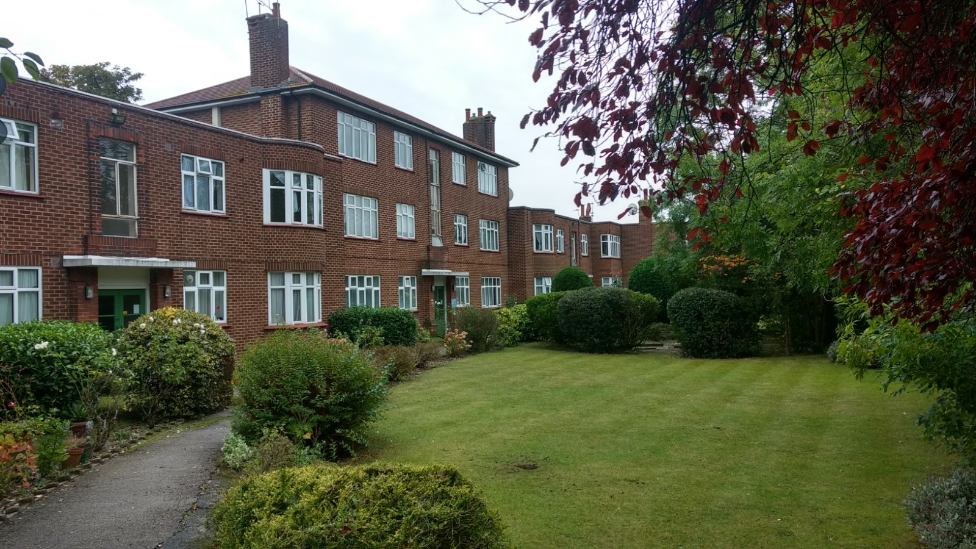

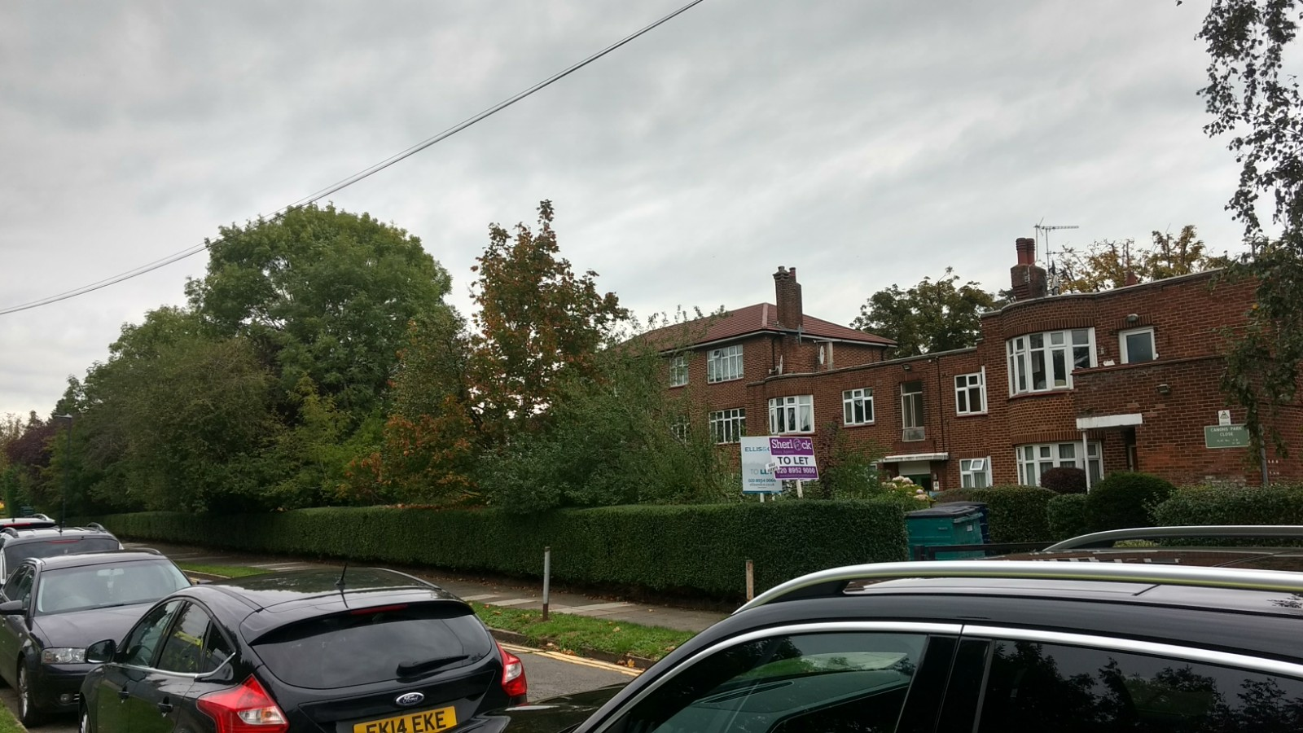

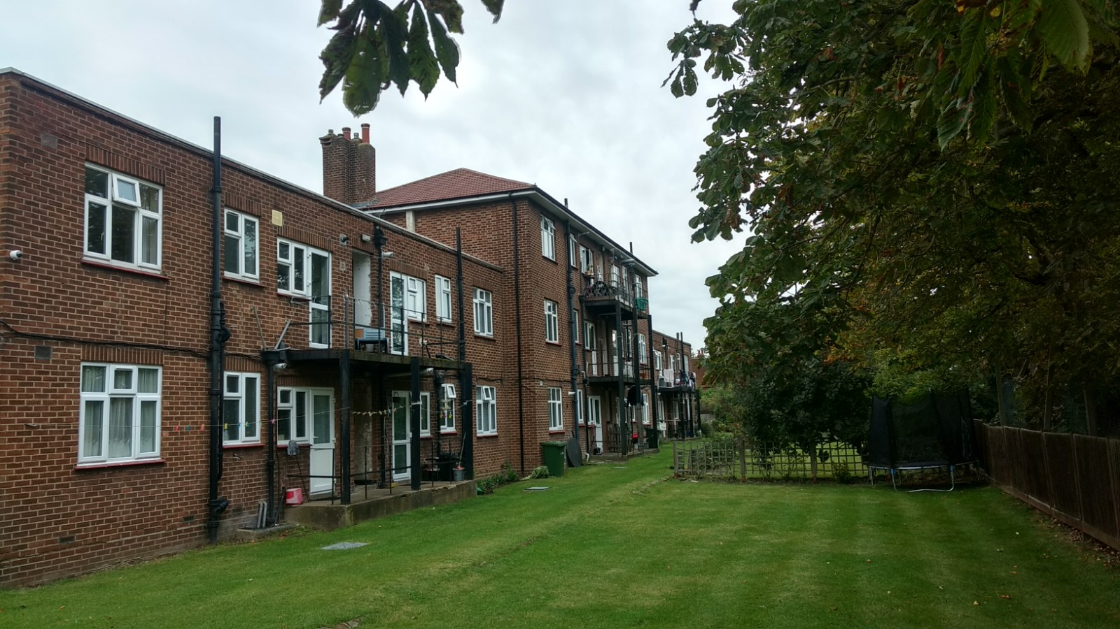

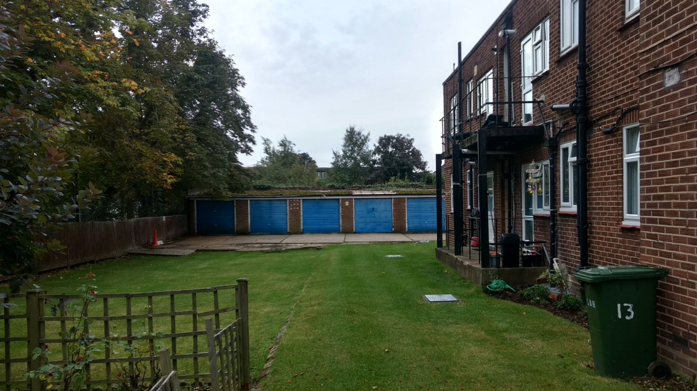
APPENDIX 4: PLANS AND ELEVATIONS

Existing Elevations
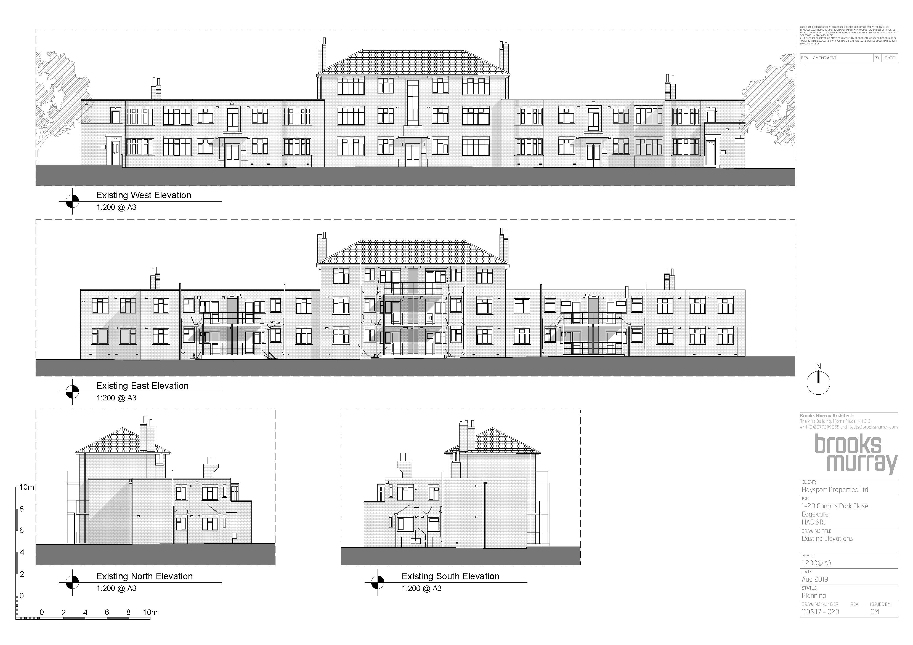

Proposed Elevations
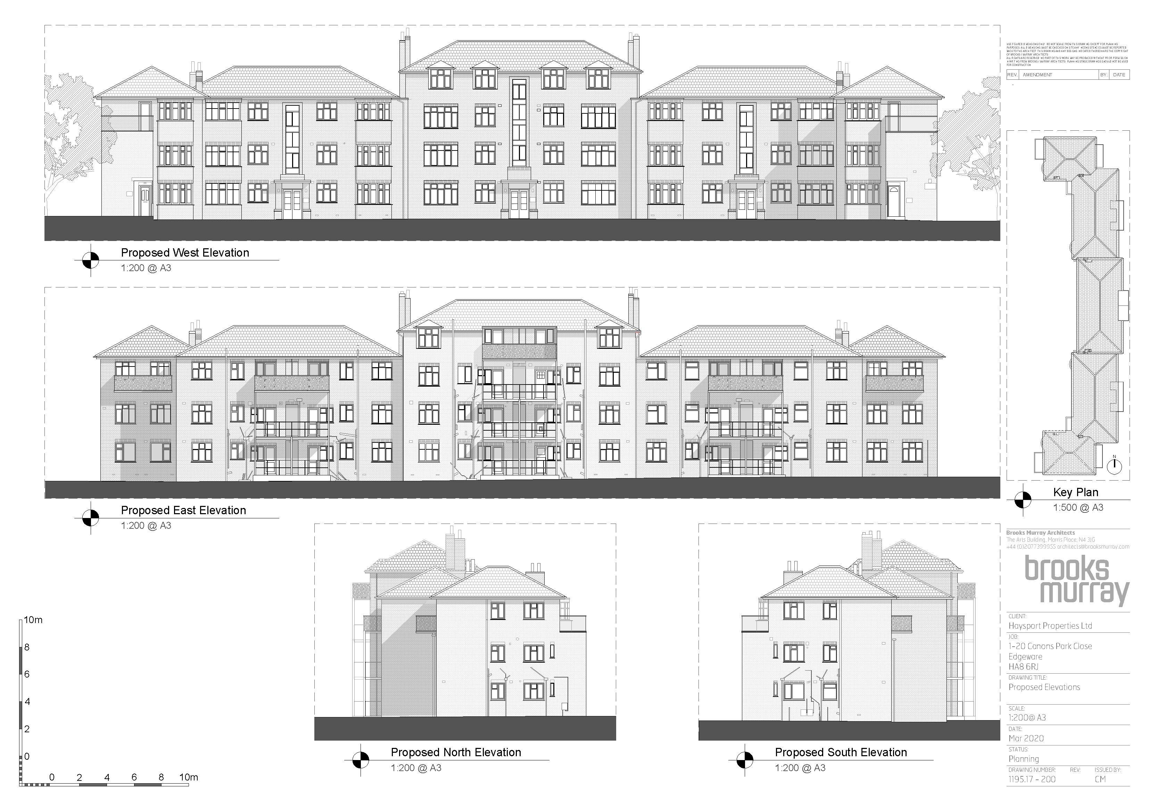
Elevation and section showing difference between proposal and approved scheme P/3837/19

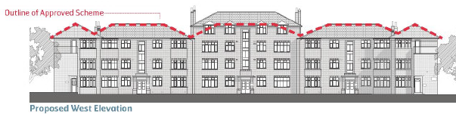

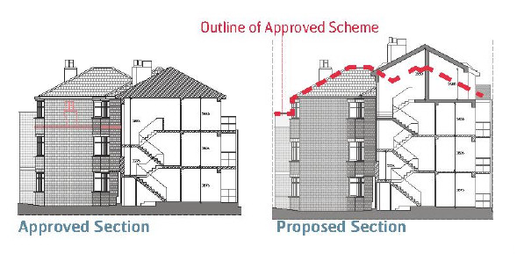

Proposed floorplan



